National University of Computer and Emerging Sciences



**Laboratory Manual**

***(Computer Programming)***

|  |  |
| --- | --- |
| Course Instructor | SarimBaig |
| Lab Instructor(s) | Ahmad Raza  WaqasManzoor |
| Section | A, B |
| Semester | Spring-2017 |
| Lab Date | 28-02-2017 |

Department of Computer Science

FAST-NU, Lahore

**Lab Manual (5)**

**(Link List)**

**Instructions:**

This is an individual Lab. You are NOT allowed to work/submit in form of group. Absolutely NO collaboration is allowed. Any traces of cheating would result in an “F” grade in this Lab.’

Keep the following good programming practices in mind when writing your code:

**• Indent your code properly.**

**• Use meaningful variable names.**

**• Use meaningful prompt lines/labels for input/output.**

**Problem 1:**

A doubly linked list is a linked list in which every node has a next pointer and a back pointer. In other words, every node contains the address of the next node (last node points to null as next node), and every node contains the address of the previous node (first node points to null as the previous node).

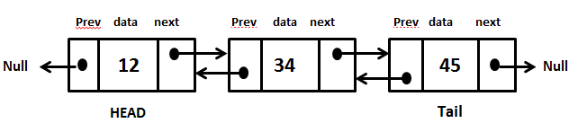

Doubly Linked List

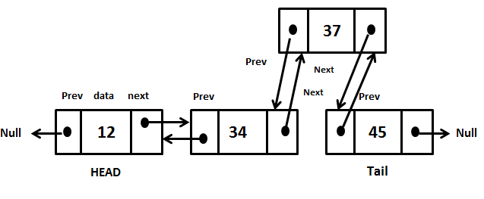

Insertion

## 

Deletion

## **Exercise**:

## Implement a doubly linked list.

Design, Develop and Implement a menu driven Program in C++ for the following operations on Doubly Linked List (DLL) of Students’ ID.

1stly, Create Doubly Link List of 1 student. Then, perform following functions:

a Perform Insertion and Deletion at Front of DLL

b. Perform Insertion and Deletion at End of DLL

c. Perform Insertion and Deletion in the middle of DLL

e. Display the data of DLL and count the number of nodes in it

f. Exit

***Remember:*** *Honesty always gives fruit (no matter how frightening is the consequence); and*

*Dishonesty is always harmful (no matter how helping it may seem in a certain situation)!*